

**Ethics Pledge**

**Consistent with the above statements, all homework exercises, tests and exams that are designated as individual assignments MUST contain the following signed statement before they can be accepted for grading.**

I pledge on my honor that I have not given or received any unauthorized assistance on this assignment/examination. I further pledge that I have not copied any material from a book, article, the Internet or any other source except where I have expressly cited the source.

Signature: Haodong Zhao Date: Apr 11th .2019

Please note that assignments in this class may be submitted to www.turnitin.com, a web- based anti-plagiarism system, for an evaluation of their originality.

**Question a:**

**Answer:**

I pick factors A and B here and their level combinations are:

(+ +) = 5 runs

(- +) = 5 runs

(+ -) = 5 runs

(- -) = 5 runs

Therefore, the design is indeed orthogonal for the main effects.

**Question b:**

**Answer i.**

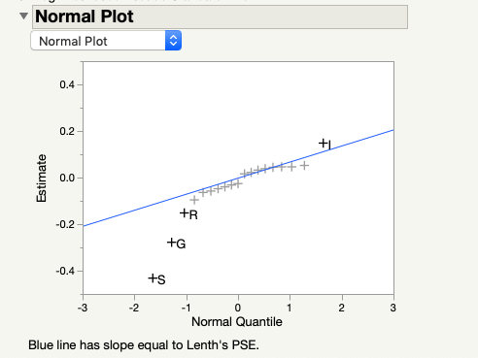

From the plot, factors S, G, R and I seem to be significant.

**Answer ii.**

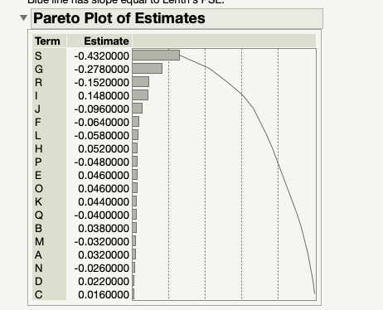

**Answer iii.**

Z0.05/2 = 1.96, nN = 100000, $\overline{p}$ = 1.298%

Standard error (effect) = $\sqrt{\frac{\overline{p} ( 1- \overline{p} )}{nN/2}+\frac{\overline{p} ( 1- \overline{p} )}{nN/2}}$ = 7.159 * 10-4 = 0.07159%

Confidence interval = effect ± Z0.05/2 * standard error (effect) = 1.403 * 10-3 = 0.1403%

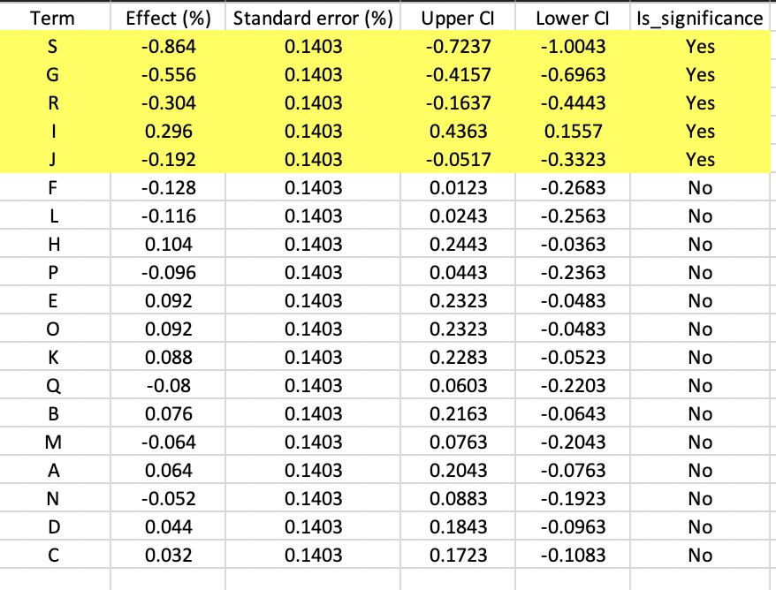

We can find the confidence intervals of S, G, R, I and J don’t include 0. Therefore, we can say in 95% confidence interval, factors S, G, R, I and J are significant.